

**CONTACT: FOR IMMEDIATE RELEASE**

Jill Schichter

[jschichter@coactive.com](mailto:jschichter@coactive.com)  
[www.thecoaches.com/pressroom](http://www.thecoaches.com/pressroom)

To view this release online, <http://www.thecoaches.com/pressroom/3rd-edition>

**Best-Selling “Bible of Coaching” Now in Third Edition**

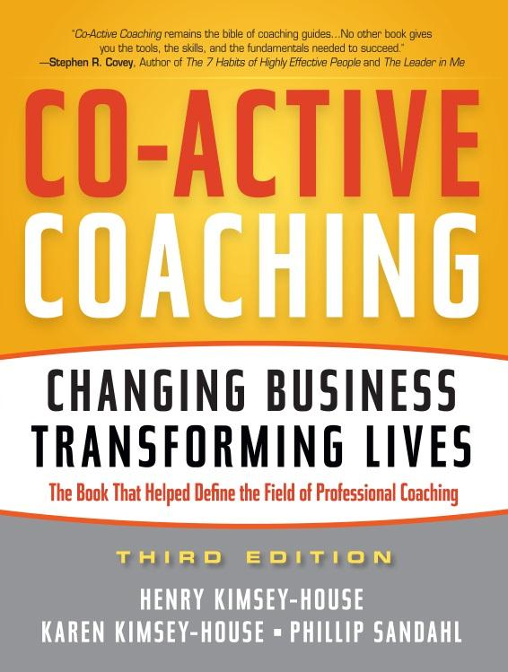*Co-Active Coaching* relaunched for 20th anniversary of coaching profession

SAN RAFAEL, CA, August 31, 2011 – When *Co-Active Coaching* was first released in 1998, this pioneering work set the stage for what has become a cultural and business phenomenon and helped launch the profession of coaching. Required reading in many professional development and university-based executive coaching programs, and the go-to guide used by thousands to elevate their communication, relationship and coaching skills, *Co-Active Coaching* became a perennial best-seller of the training and development industry.

Now the release of the newly revised third edition marks the 20th anniversary of both the coaching profession and the first coaching courses taught by the authors, the founders of [The Coaches Training Institute](http://www.thecoaches.com) (CTI), the oldest and largest in-person coach training school in the world.

“With its third updated edition, *Co-Active Coaching* remains the bible of coaching guides,” says Stephen R. Covey, best-selling author of *The 7 Habits of Highly Effective People*. “Written with a powerful, distinctive approach, no other book gives you the tools, the skills and the fundamentals needed to succeed in these delicate relationships.”

The third edition features an array of new material:

* The expanded vision of the newly updated Co-Active Model
* How to use the material in leadership management and throughout organizations
* An on-line toolkit with updated coaching tools that replaces the CD of the last edition
* New coaching demonstrations
* 35+ updated exercises, questionnaires, checklists and reproducible forms

The Co-Active Model featured in *Co-Active Coaching* has always encompassed a philosophy, a methodology, a skill set and a communication form that balances self-awareness, relationship intelligence and courageous action so people can be deeply fulfilled, connected to others and successful in what matters most. The Co-Active Model is the foundation of all the courses taught by CTI, and it is being applied in business, education, medicine, government, communities and families around the world.

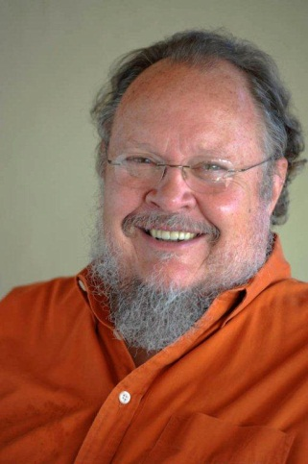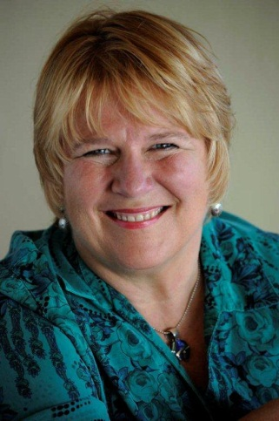

**Henry Kimsey-House Karen Kimsey-House Phillip Sandahl**

**Authors, *Co-Active Coaching***

“But the old Co-Active Model was about incremental change; the new one is about transformational change,” says co-author Henry Kimsey-House, a co-founder of CTI. “We discovered coaches were following the client’s agenda too literally, for better or worse. We didn’t teach it that way, but that’s how it was sometimes interpreted. We’ve tightened the bolts down now. The coach’s job is now defined as evoking transformation. The coach doesn’t decide what the transformation is but holds it firmly as the goal. If no major shifts are happening, it’s wimpy coaching. Drive and deliver – the masculine was what was missing in the old model.”

Another key reason the Co-Active Model and the book were updated was “to reflect our expanded vision of seeking global transformational change,” says co-author Karen Kimsey-House, the CEO of CTI. “Our profession was born into celebration of the individual and a commitment for people to be individually unique and magnificent. The time has come to put our attention on the whole, the collective and the undeniable relationship that we have with every other speck of life in this wondrous universe. We belong to one another. Whether we *like* that or not is of little consequence: It’s sort of like standing out in the rain and having a disagreement with a hurricane.”

Indeed, with the guidance of *Co-Active Coaching*, many coaches, managers, executives, parents, leaders and educators have already begun to seek both personal and global transformational change, from becoming the president of an international university with the mission of shaping students into global citizens, to changing the culture of one of the largest community foundations in the U.S…from mentoring third-world girls through college in the U.S., to coaching Japan’s earthquake and tsunami survivors…from coaching diabetes patients to reduce their need for insulin, to growing a start-up consultancy of a major technology company 38% in a down market.

“Transformation is confusing and scary,” says Karen Kimsey-House “Our Co-Active tools and skills can be enormously helpful in facing these challenges. There are many organizations working to create a global shift and our work is an important piece of the solution. We want to inspire people to identify their piece and give it all they’ve got. If you’re interested in transformation, we’re interested in your piece, too.”

# # #

For a review copy of *Co-Active Coaching* or to set up an interview with the authors, please contact

Marcia Norris, Dir. of Marketing Communications at CTI, at [marcia@coactive.com](mailto:marcia@coactive.com) or 415-526-1603.

*Co-Active Coaching: Changing Business, Transforming Lives*, 3e

By Henry Kimsey-House, Karen Kimsey-House, Phillip Sandahl

Nicholas Brealey Publishing

**Available September, 2011**

ISBN: 978-1-85788-567-5

EISBN: 978-1-85788-906-2

Ebook editions are available through the publisher’s ebook partners: Amazon, Barnes & Noble, Books 24/7, Cyberlibris, Dawson, Ebooks Australia, ebrary, Ebsco, Google, GoSpoken, Kobo , MBS textbook, Ingram, Net Library, Overdrive, and Safari.

**About the Co-Authors**

**Henry Kimsey-House, CPCC, MCC**, one of the first professional coaches in the 1980s, is the Co-founder and head designer of the leading-edge experiential learning programs of The Coaches Training Institute (CTI), the foremost coach training school in the world. CTI and its Co-Active philosophy have revolutionized the lives and careers of over 35,000 managers, leaders and coaches throughout the world. Kimsey-House continues to develop new, innovative curriculum and is at work on a book about transformative leadership.

**Karen Kimsey-House, MFA, CPCC, MCC**, is the Co-founder and CEO of The Coaches Training Institute (CTI), the foremost coach training school in the world. One of the earliest recognized luminaries in the coaching profession, she founded CTI in 1992 with Laura Whitworth and Henry Kimsey-House. They created the Co-Active philosophy to relationship that informs CTI’s coaching and leadership programs. Kimsey-House continues to lead CTI workshops and is a popular keynote speaker around the world.

**Phillip Sandahl, CPCC, MCC,** played an important role in the international growth of coaching and is a pioneer in the field of team coaching. A former senior faculty member of CTI, he is co-founder and principal of Team Coaching International. Sandahl and co-founder Alexis Phillips are developers of the Team Diagnostic™ team effectiveness model and a suite of four integrated assessment tools used with hundreds of teams worldwide.

**About The Coaches Training Institute (CTI) and Co-Active®**

CTI is the oldest and largest in-person coach training school and one of the most innovative leadership training organizations in the world. With 35,000 students trained and courses provided in 24 countries, CTI was founded in 1992 by Karen and Henry Kimsey-House and Laura Whitworth. They developed the Co-Active Model that encompasses a philosophy, a methodology, a skill set and a communication form that balances self-awareness, relationship intelligence and courageous action so that people can be deeply fulfilled, connected to others and successful in what matters most. The foundation of all of CTI’s training, the Co-Active Model is being applied in business, education, medicine, government, communities and families around the world. CTI’s world headquarters are in San Rafael, California. [www.thecoaches.com](http://www.thecoaches.com) 1-800-691-6008

**Praise for the Third Edition of *Co-Active Coaching***

“With its third updated edition, *Co-Active Coaching* remains the bible of coaching guides. Written with a powerful, distinctive approach, no other book gives you the tools, the skills and the fundamentals needed to succeed in these delicate relationships.”

— **Stephen R. Covey, best-selling author of *The 7 Habits of Highly Effective People***

“*Co-Active Coaching* should be required reading for every manager or employee who wants to succeed in the workplace.”

* **Marshall Goldsmith, author of the *New York Times* best-sellers *MOJO* and *What Got You Here Won't Get You There***

“*Co-Active Coaching* exudes the catalytic power to transform your organization and your life. Read it, savor it and practice it to become a purpose-filled leader of life!”

* **Kevin Cashman, best-selling author, *Leadership from the Inside Out* and *Awakening the Leader Within***

“Transformational change – in ourselves, or in the teams, organizations, and companies we lead – is ultimately all about relationships. The third edition of *Co-Active Coaching*, by the eloquent and compassionate founders of The Coaches Training Institute, will give you the tools, the skills, the strategies and the ethical frameworks to achieve the powerful goals of this work: Changing lives and changing the world.”

* **Celeste Schenck, President, American University of Paris**

“*Co-Active Coaching* insightfully reveals how to unlock a person’s potential and enlighten their past, present and future. It’s a must-read for all self-empowered senior executives.”

* **Michael Cheah, former President of Xian Janssen Pharmaceutical, China (A Johnson & Johnson Group of Companies)**

“Coaching basics are an essential skill set for any manager or leader who is interested in developing other people, so I use *Co-Active Coaching* material in most of the MBA courses I teach. Without fail, it engages the hearts and minds of people who care about acquiring meaningful and effective skills they can immediately put to use.”

* **Heidi Brooks, Ph.D., Director of Yale School of Management Mentoring Program, Lecturer at Yale School of Management, Clinical Assistant Professor at Yale School of Medicine, Department of Psychiatry**

“I applaud the new edition of this definitive text on transformational coaching. The authors and the visionary network they lead provide an effective methodology to work with change at personal and organizational levels. This is a must-read for professionals who value the process of discovery, awareness, and choice that empowers people to find their own inner wisdom and to act in service to make a better world for all.”

**— Lynne Twist, Author, The Soul of Money, Founder, Soul of Money Institute, and Co-Founder, The Pachamama Alliance**

“When designing our ICF ACTP coach certification program, we never considered any textbook other than *Co-Active Coachin*g. This is the best, most comprehensive book for teaching the relevant skills of coaching. It should be required reading for all coach-specific training programs in any environment (profit, non-profit, executive, teams, etc.). With the enhancements made in the third edition, we look forward to incorporating this edition into our required reading list.”

**—Donna Billings, PCC and Co-founder, Professional Coach Certification Program, Duquesne University School of Leadership and Professional Advancement**